# 1 .I NTRODUCTION

OVERVIEW

A Human Resources (HR) Assistant is a professional who is responsible for the daily administrative and HR duties of an organization. They assist with recruitment and record maintenance for payroll processing as well as provide clerical support to all employees.

PURPOSE

Designing and updating job descriptions

Sourcing potential candidates from various online channels (e.g. social media and professional platforms like Stock overflow)

Crafting recruiting emails to attract passive candidates



We are looking for an HR Recruiter to manage our full cycle recruitment, from identifying potential hires to interviewing and evaluating candidates.

HR Recruiter responsibilities include sourcing candidates online, updating job ads and conducting background checks. If you have experience with various job interview formats, including phone screenings and group interviews, and can help us recruit faster and more effectively, we’d like to meet you.

Ultimately, you will play an important part in building a strong employer brand for our company to ensure we attract, hire and retain the most qualified employees.

# 2. PROBLEM DEFINITION &DESIGN THINKING

EMPATHY MAP

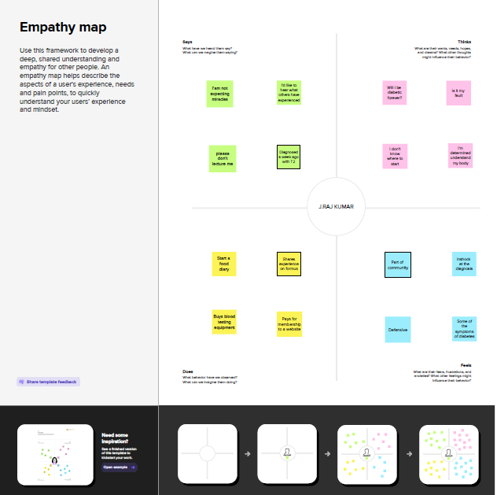

IDEATION & BRAINSTORM MAP

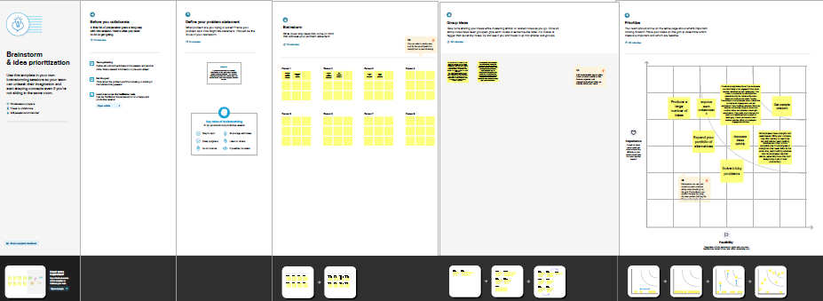

# 3. RESULT

DATA MODEL

|  |  |  |  |  |  |  |  |  |
| --- | --- | --- | --- | --- | --- | --- | --- | --- |
| OBJECT NAME | FIELD IN THE OBJECT | | | | | | | |
| Job posting sites | |  | | | | | | | |
|  | FIELD LABEL | | DATA TYPE | | |  | |
| Job posting site | | URL | | |
|  | | | | |
|  | | | | | | | |
| Technical sites |  | | |  | | |  | |
| FIELD LABEL | | DATA TYPE |
| Technical site | | URL |
|  | | |

# 

|  |  |  |  |  |
| --- | --- | --- | --- | --- |
| OBJECT NAME | FIELD IN THE OBJECT | | | |
| Status |  | | | |
|  | FIELD LABEL | DATA TYPE |  |
| Status | URL |
|  | | | |
| Description | |  |  | | --- | --- | | FIELD LABEL | DATA TYPE | | Description | URL | | | | |
| Job Posting | |  |  | | --- | --- | | FIELD LABEL | DATA TYPE | | Job posting | URL | | | | |

ACTIVITY & SCREENSHORT

Milestone-1: Creation of developer account

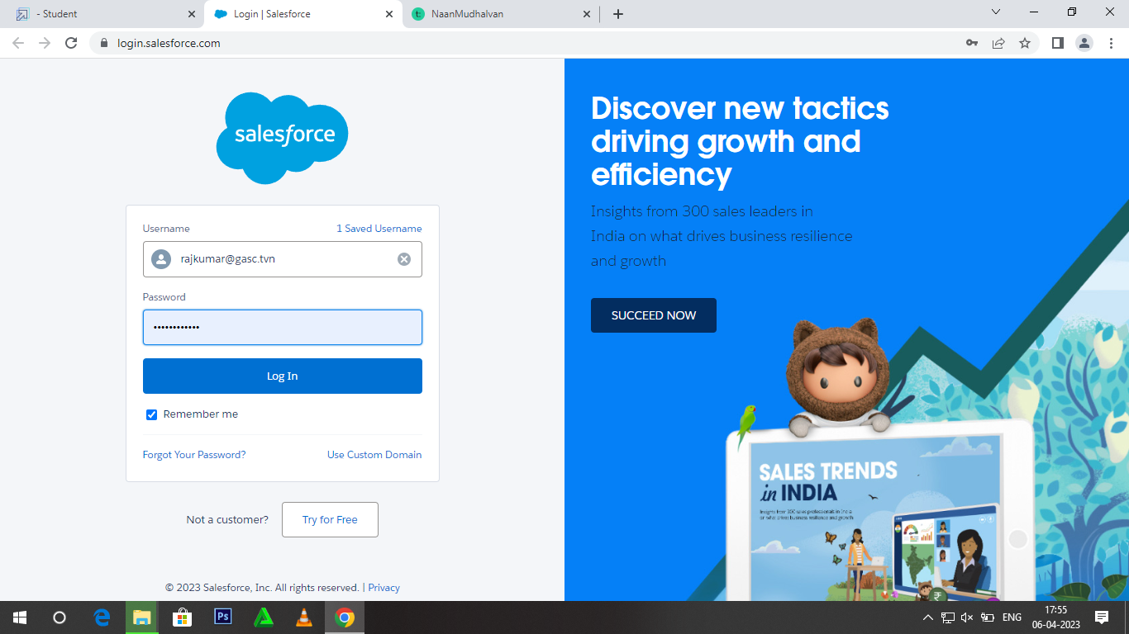

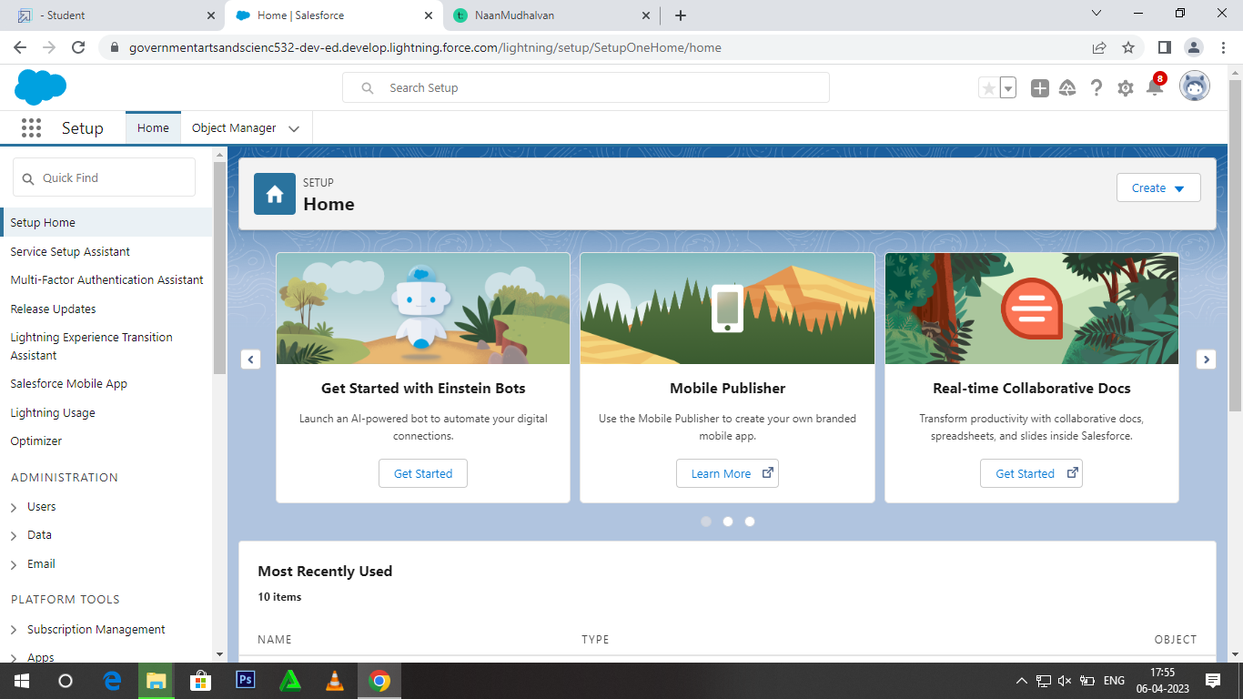

Milestone-2: Package Installation

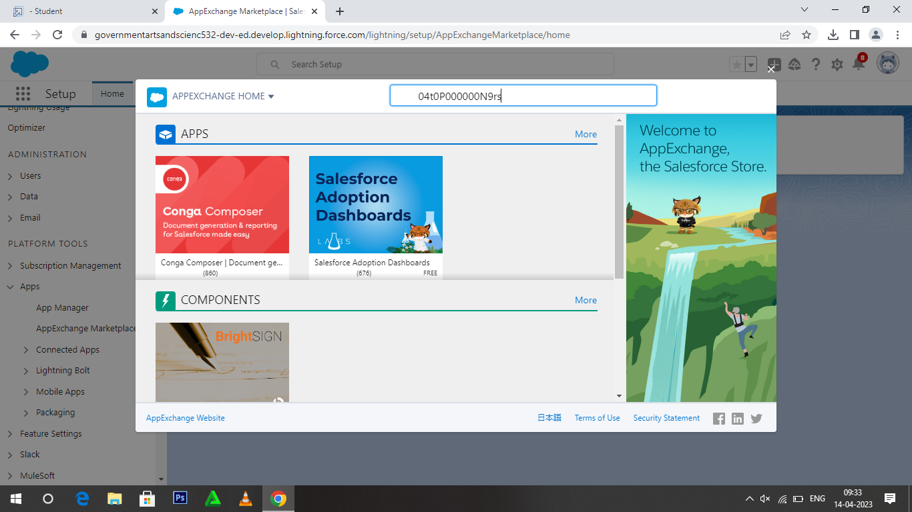

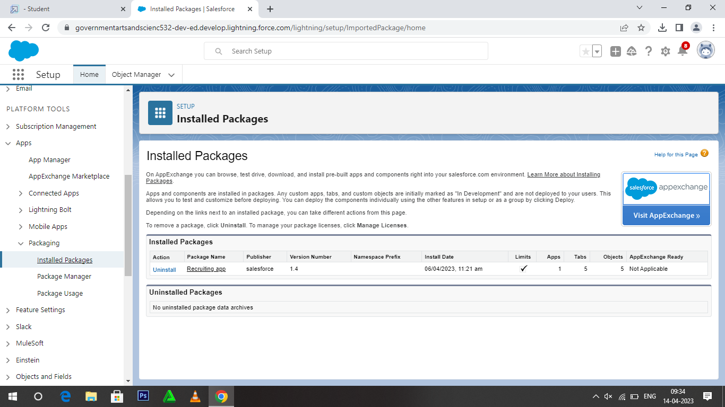

Milestone-3: Object

Activity-1

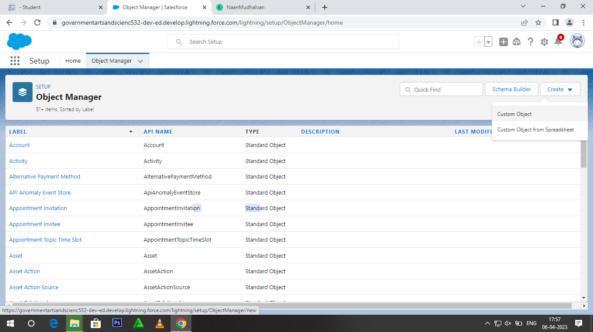

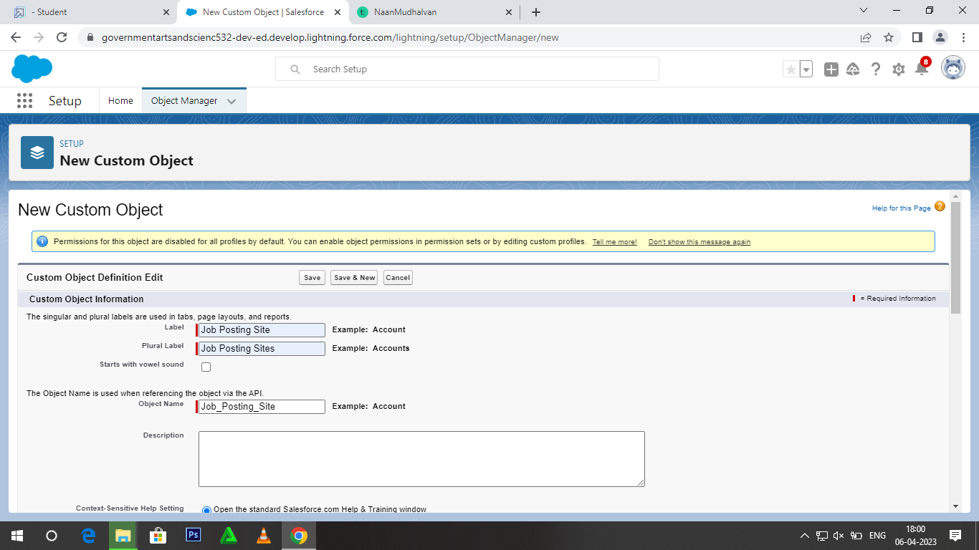

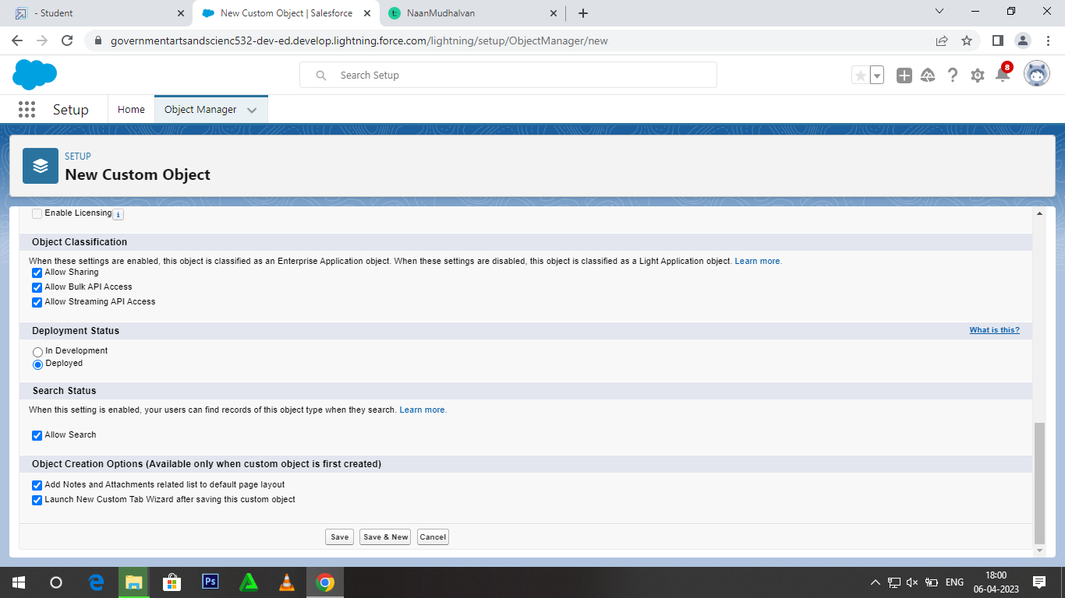

Activity-2

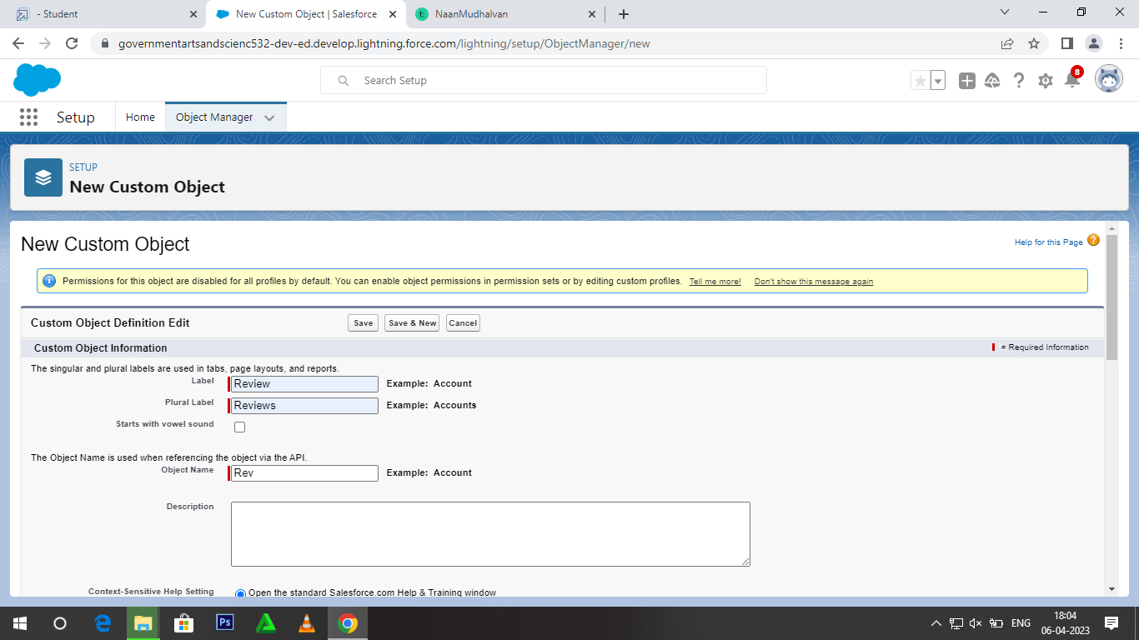

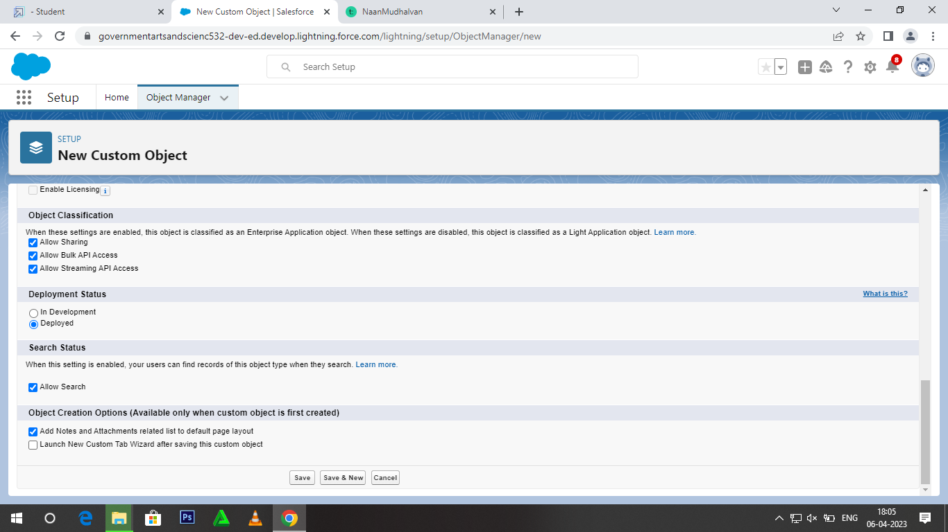

Milestone-4: Tabs

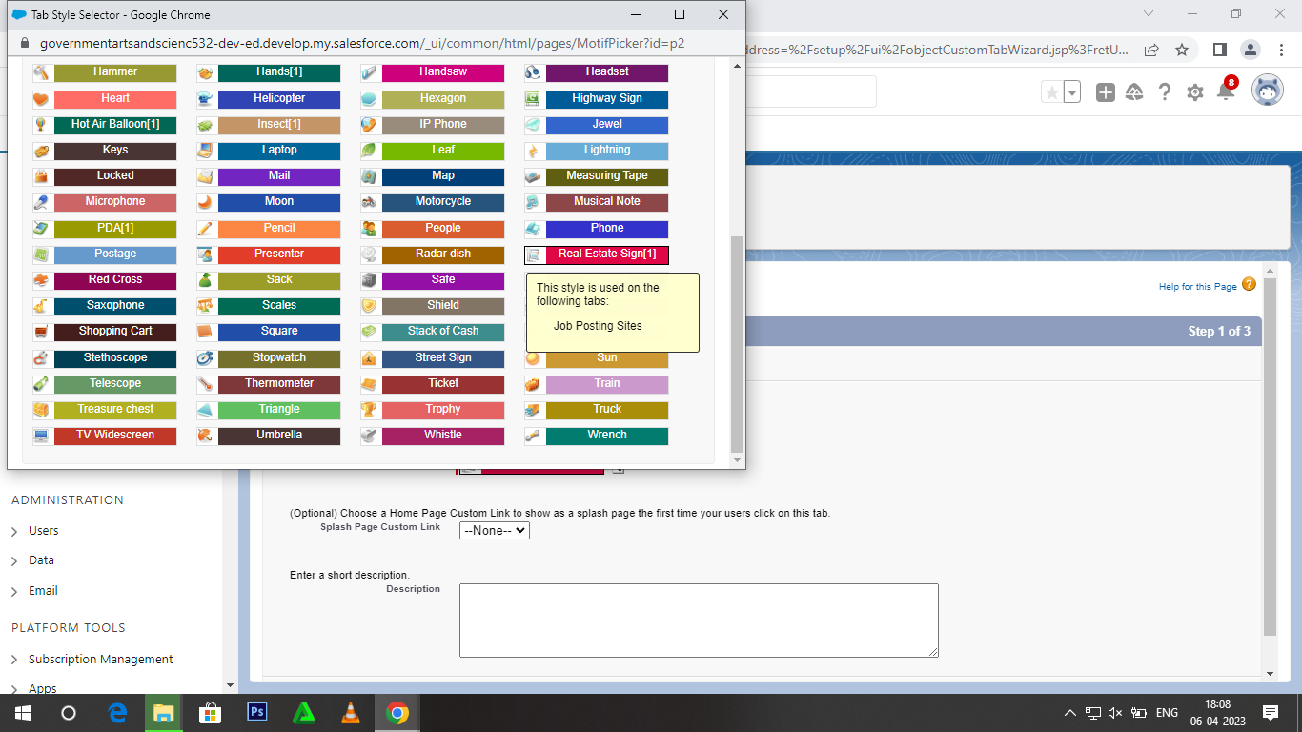

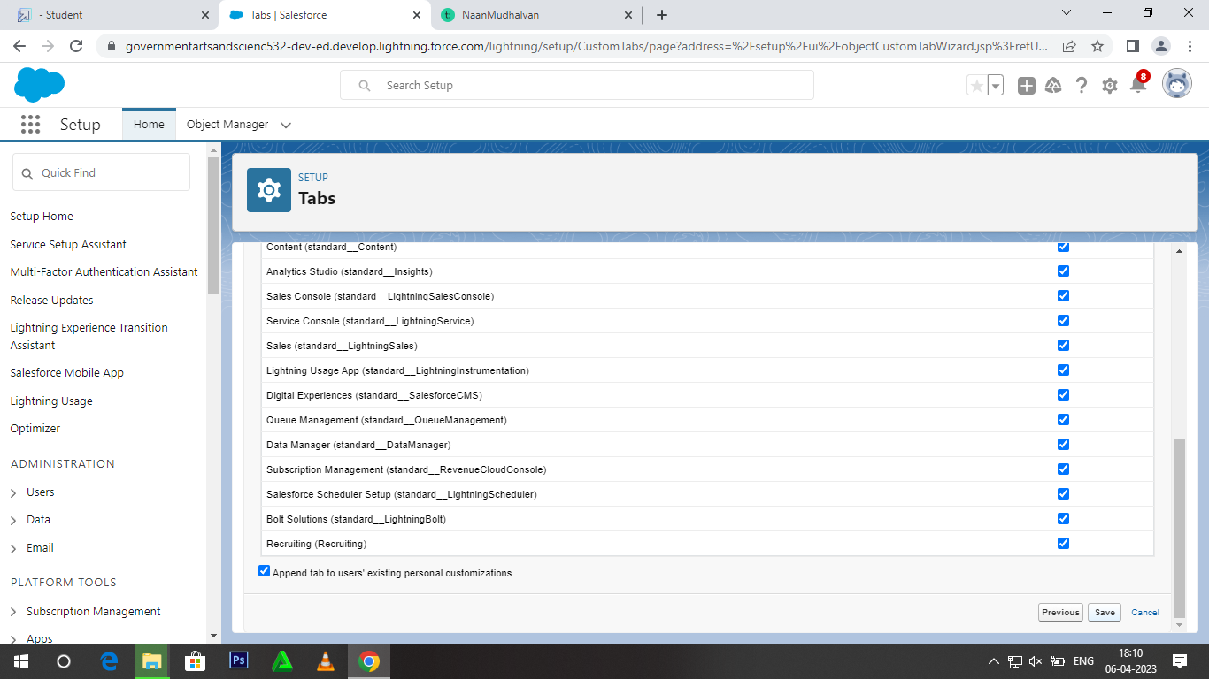

Milestone-5: Fields

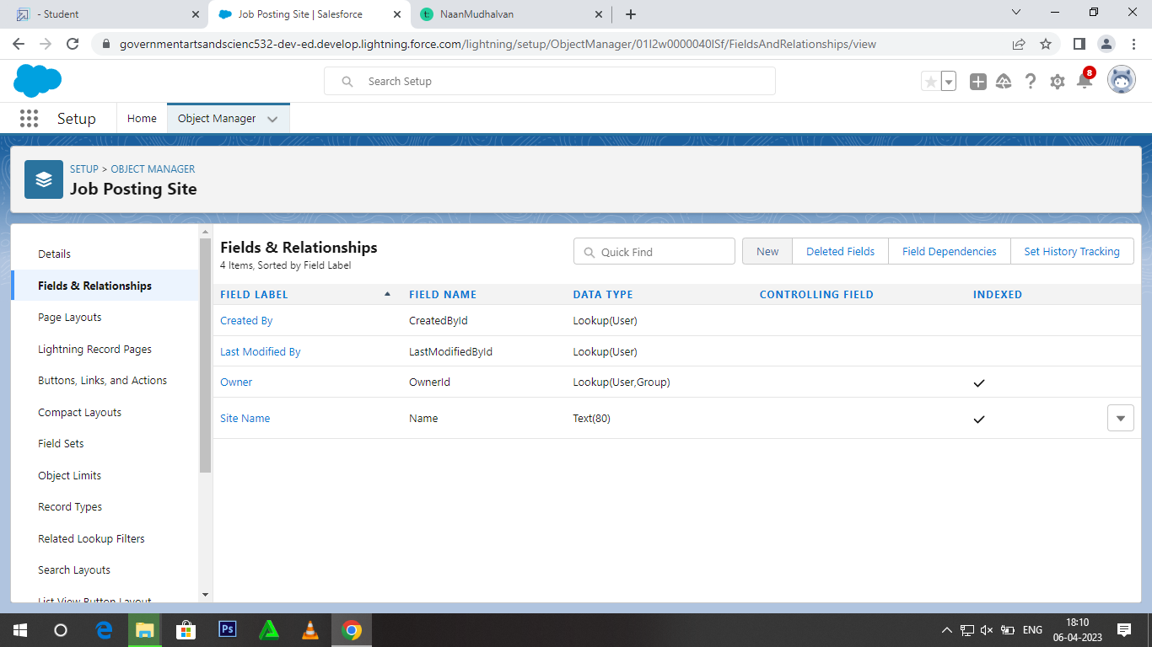

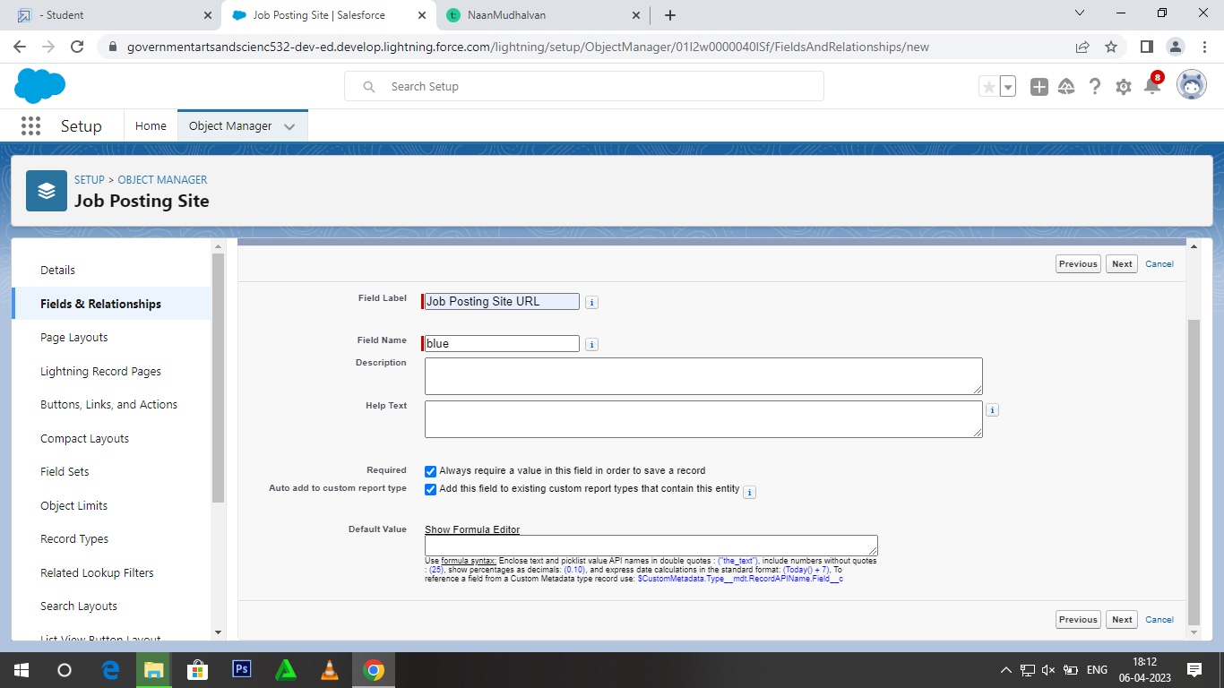

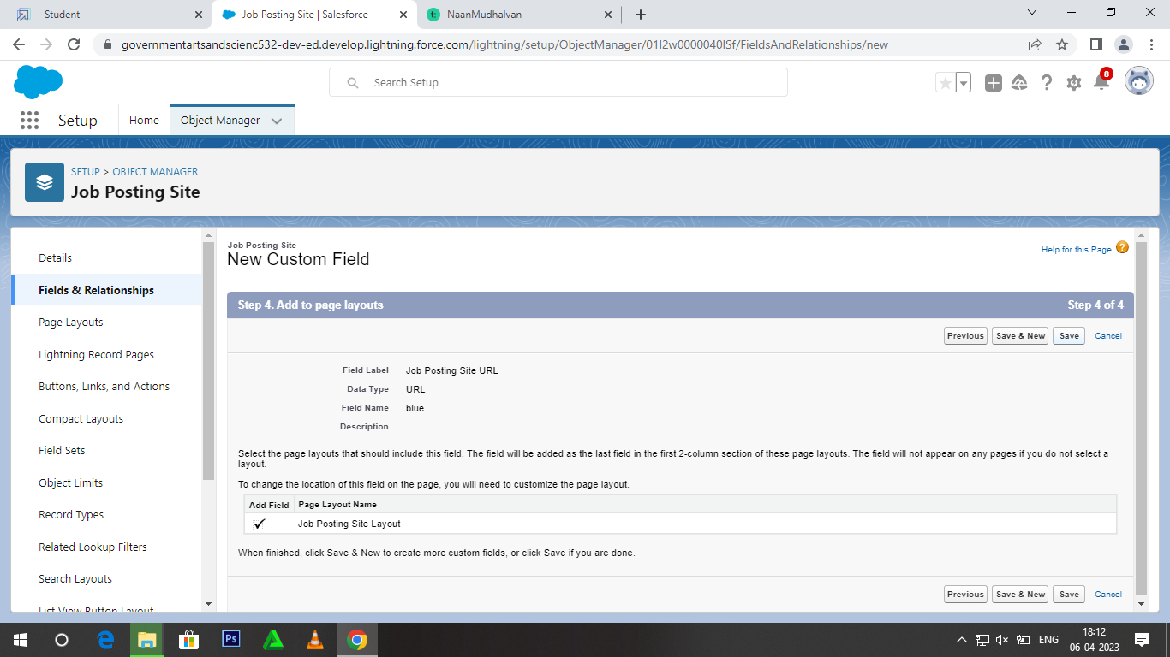

Milestone-6: Junction object

Activity-1

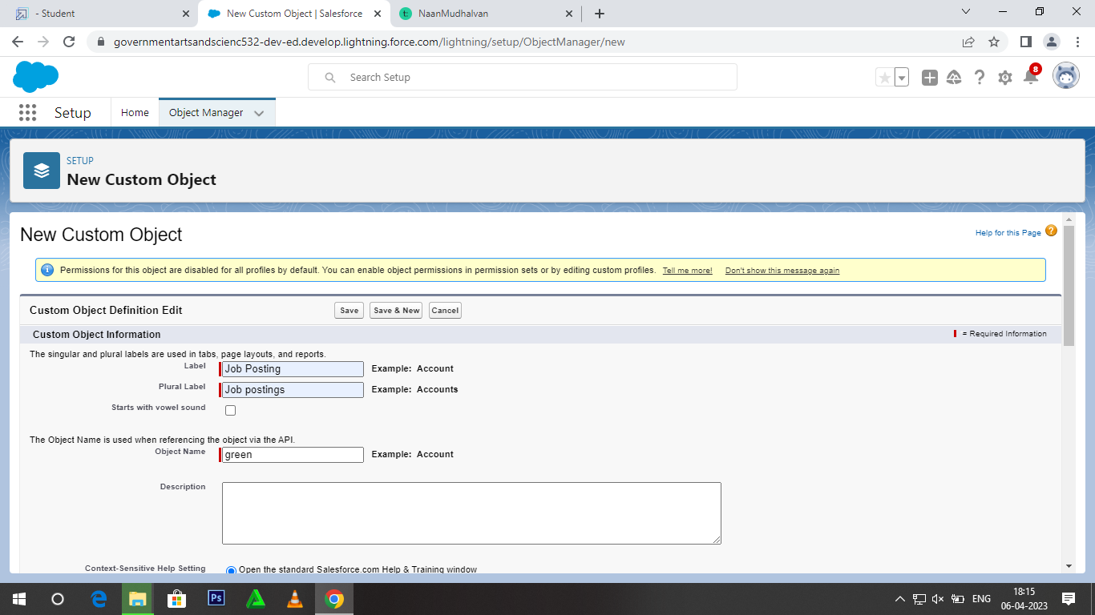

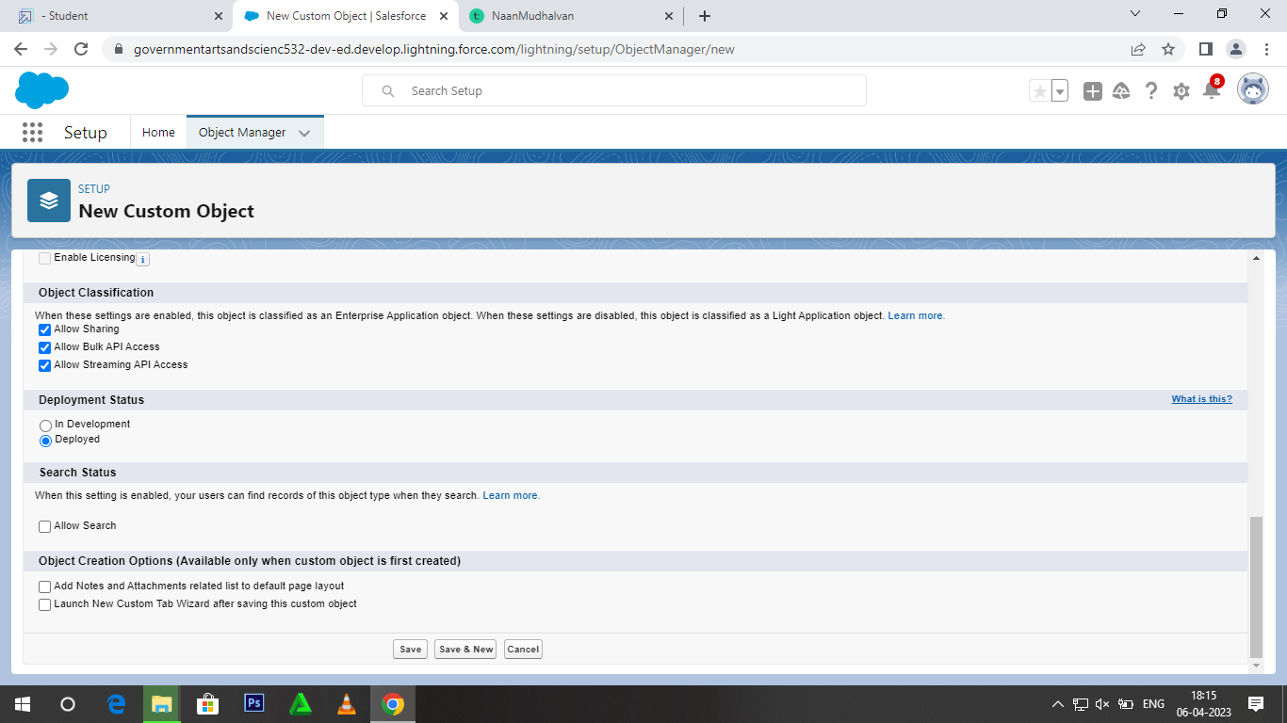

Activity-2

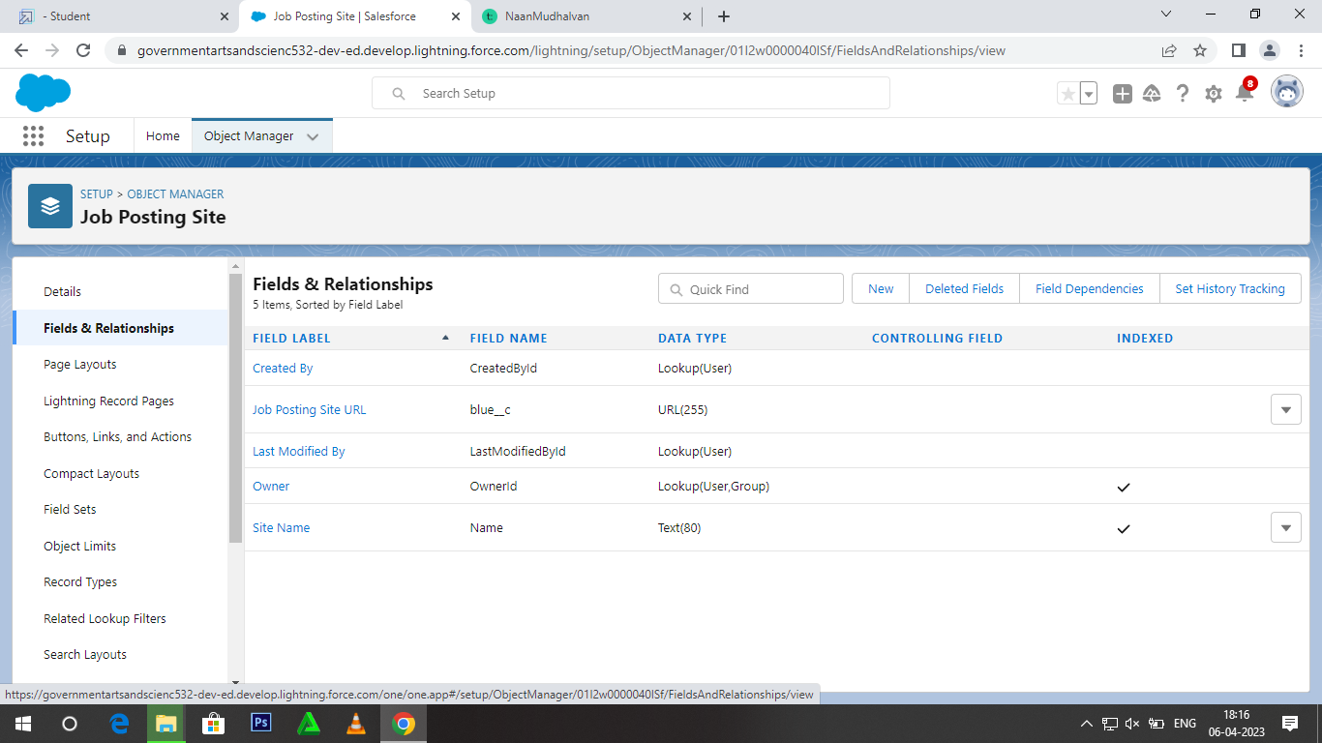

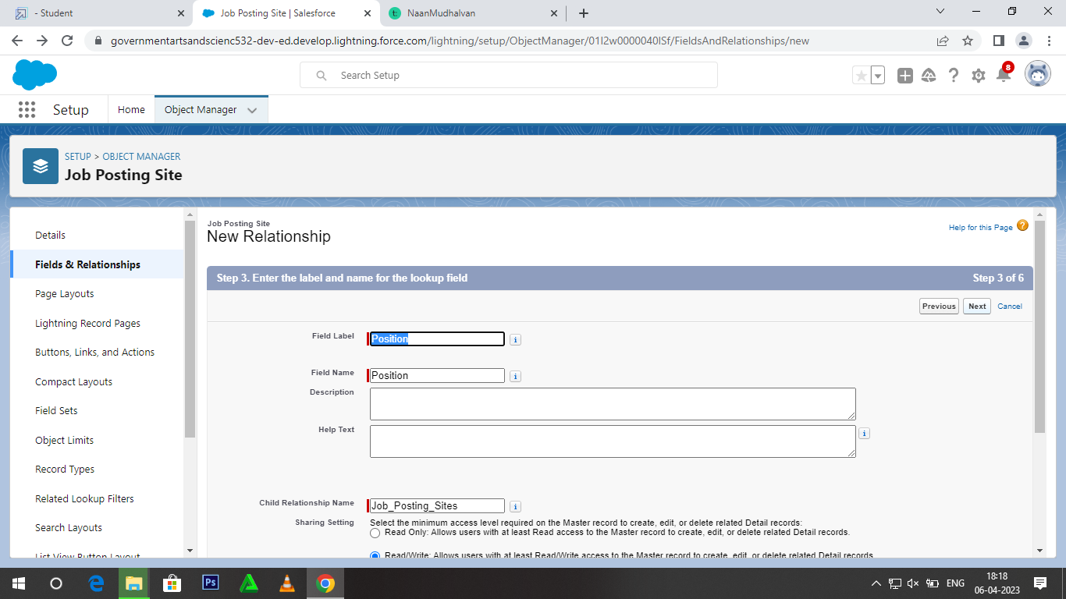

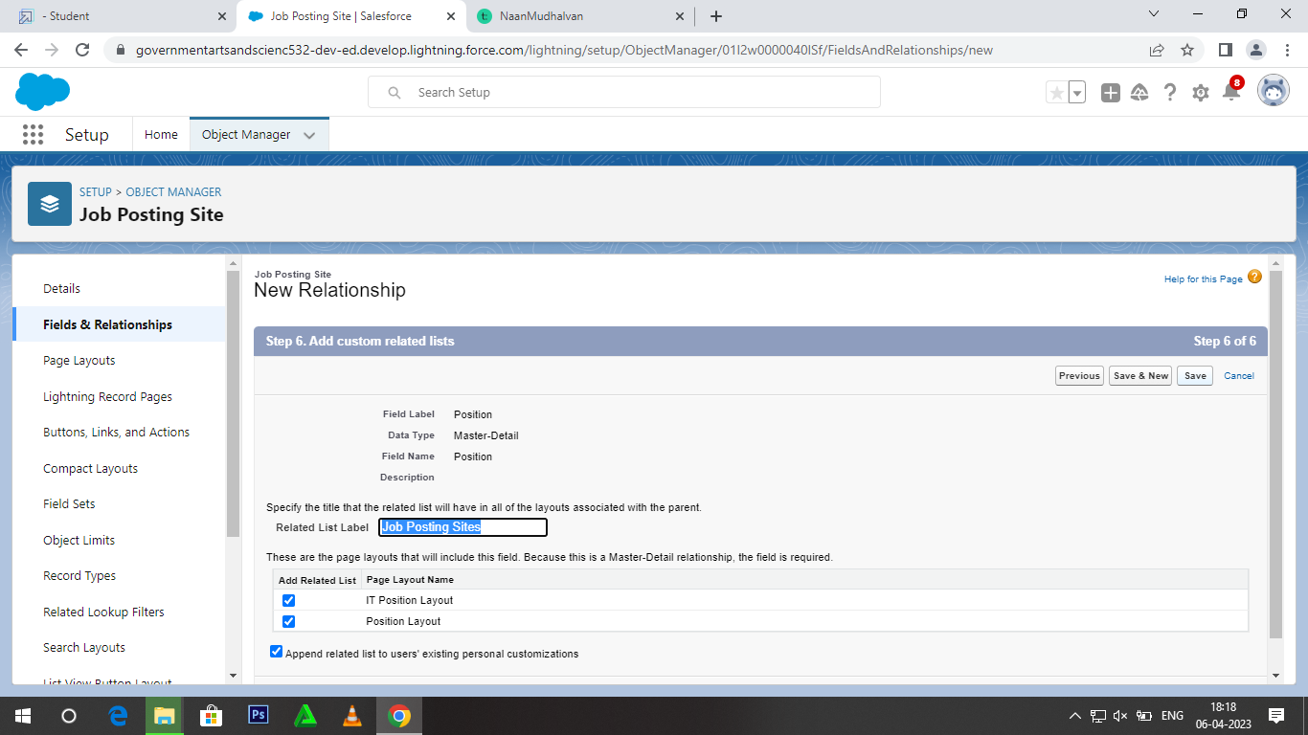

Mileston-7: Page layouts

Activity-1

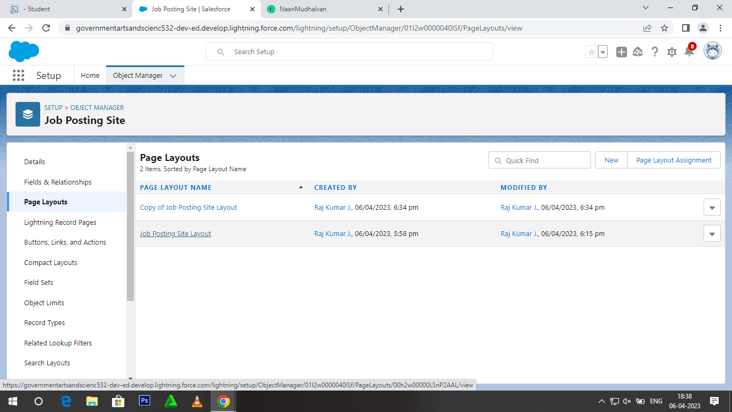

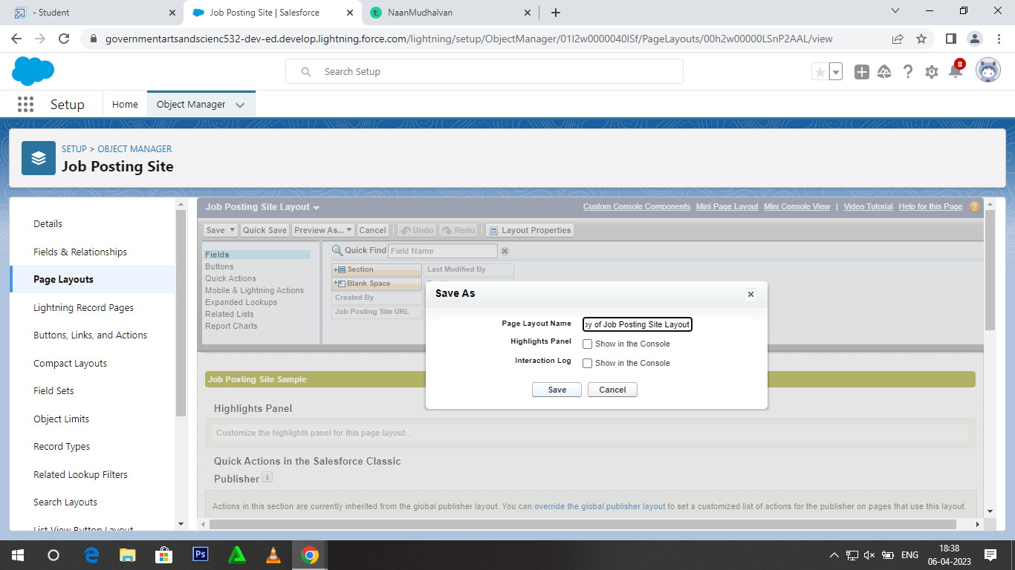

Activity-2

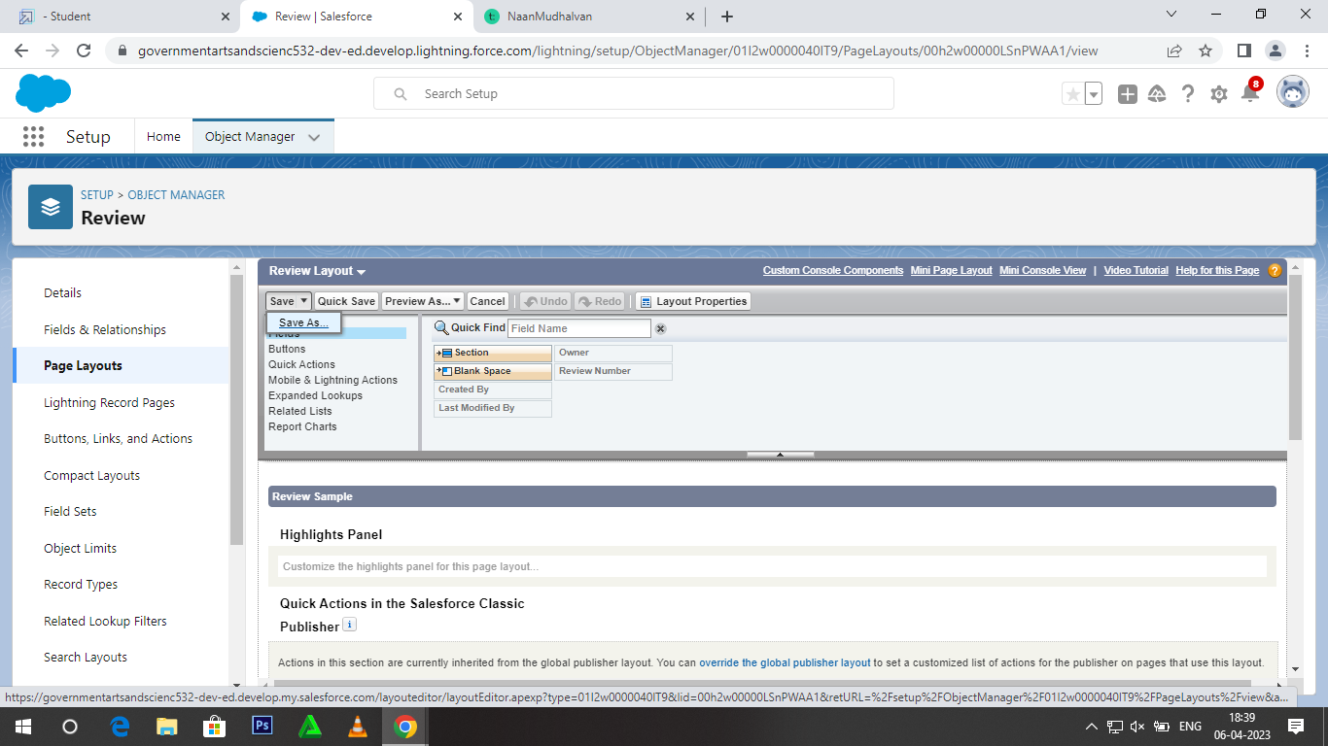

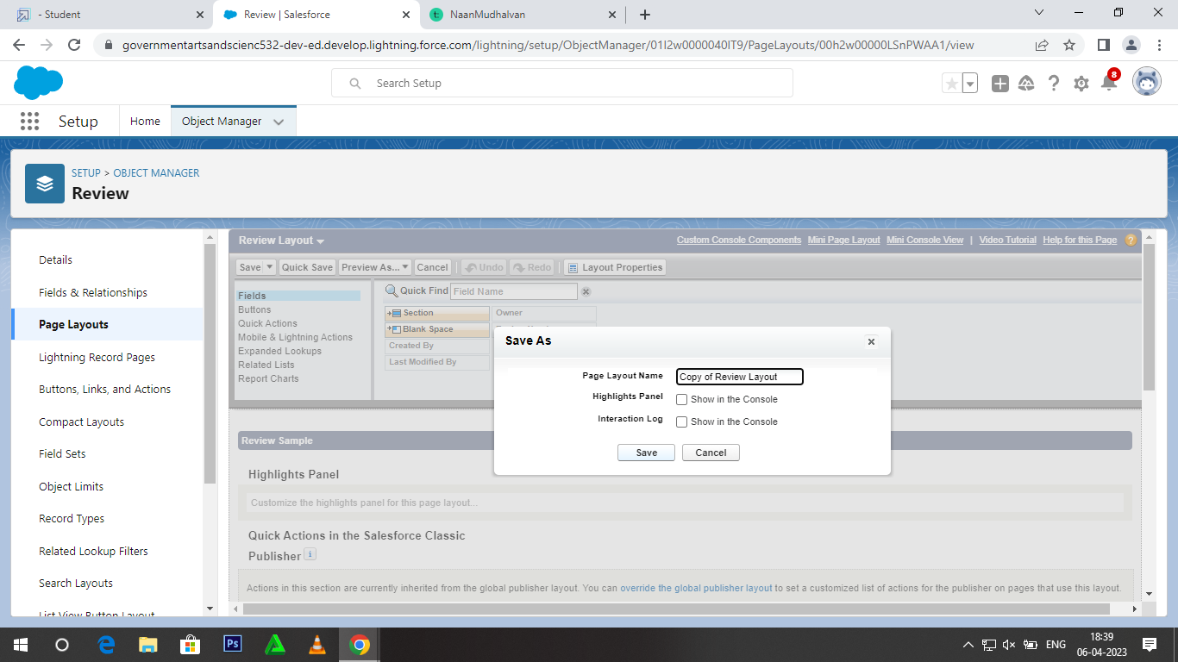

Milestone-8: Validation Rule

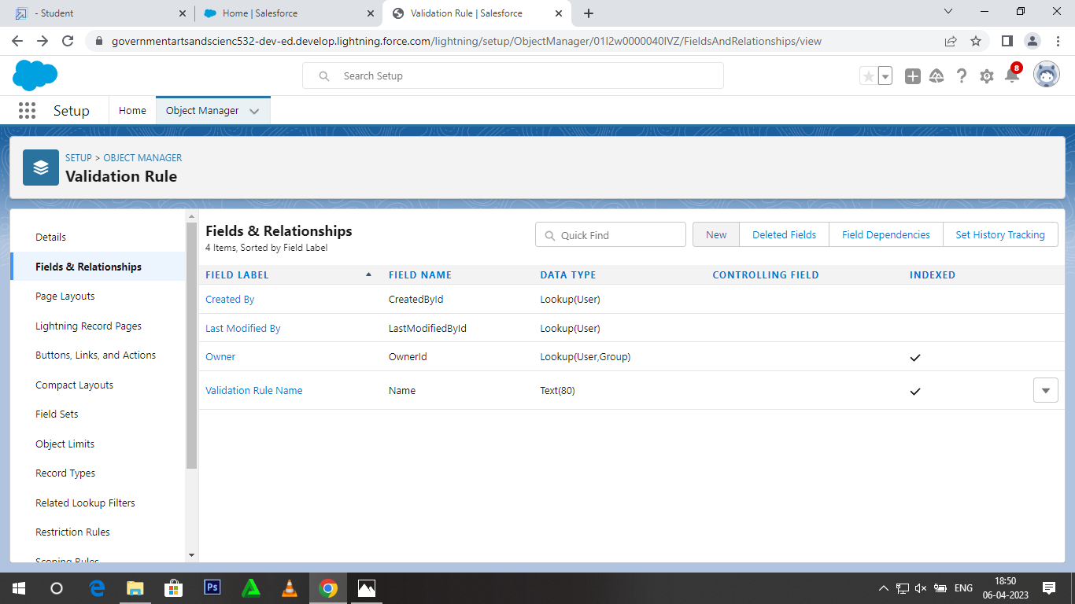

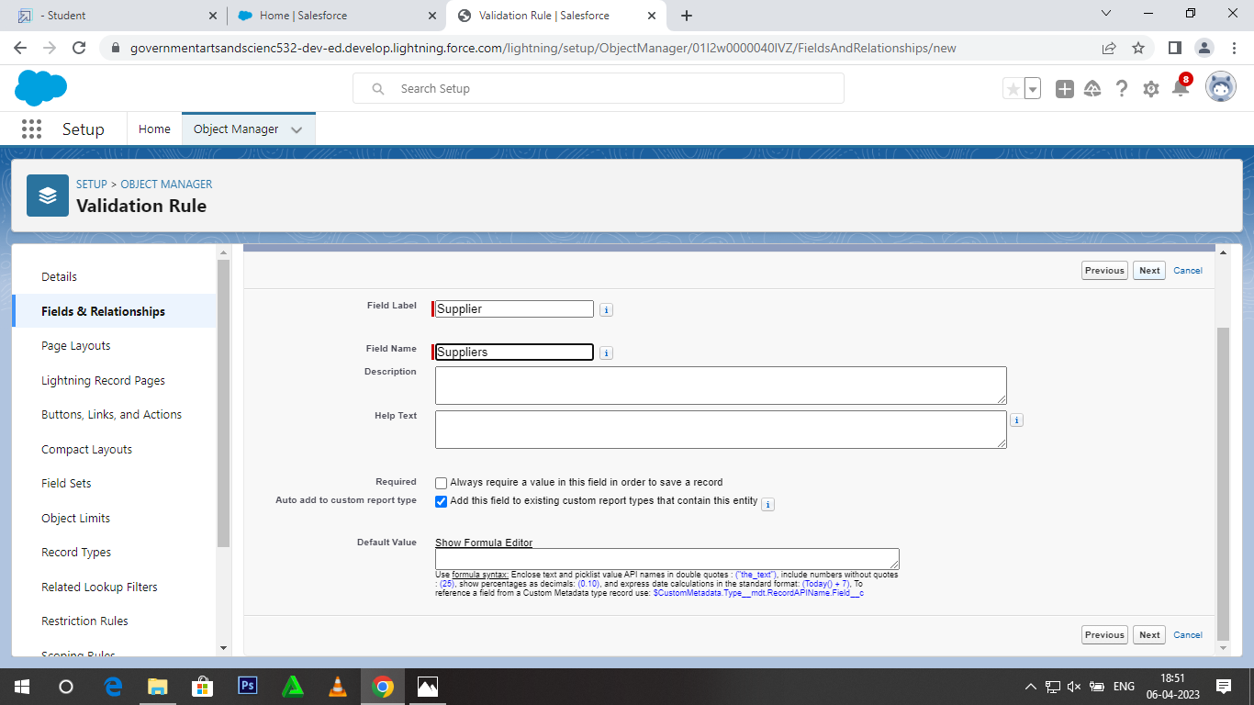

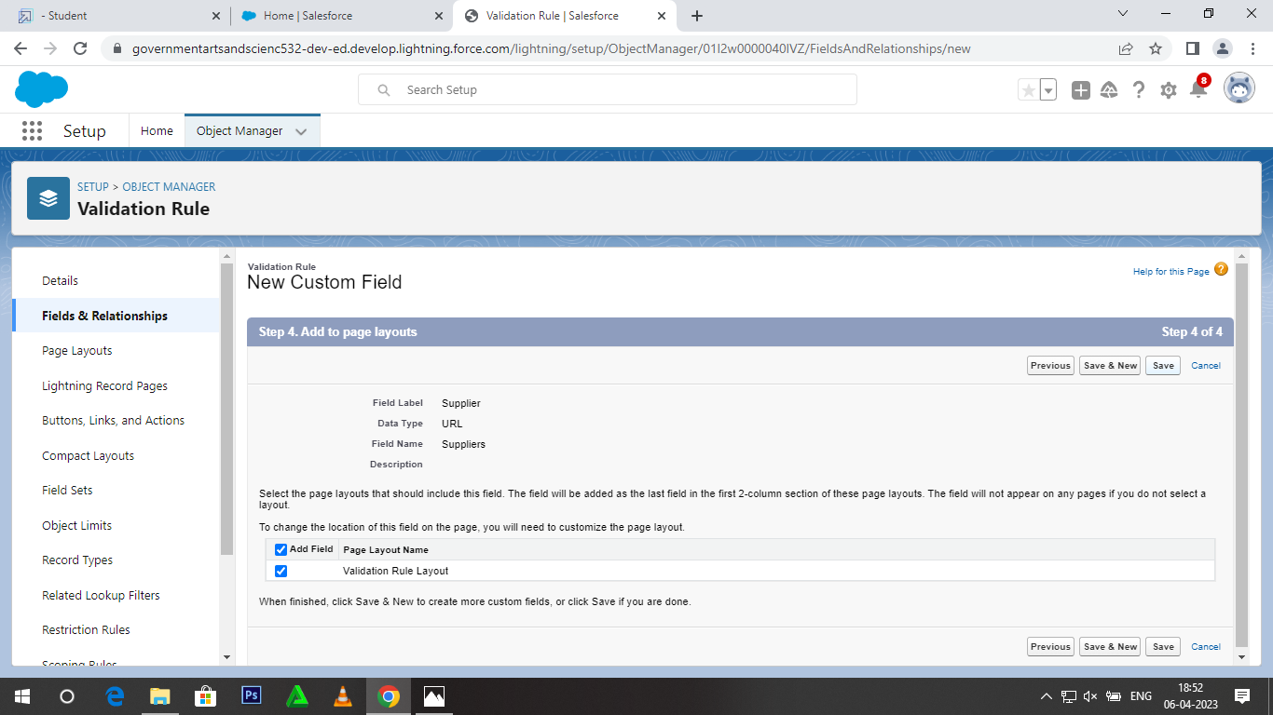

Milestone-9: Profile

Activity-1

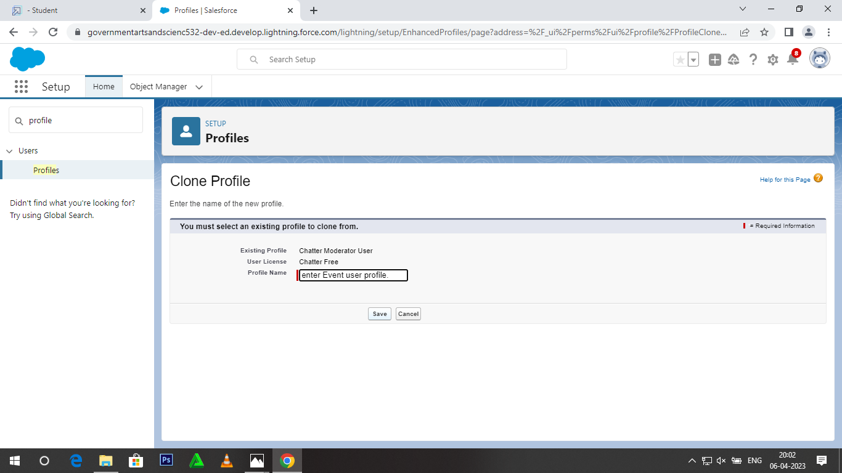

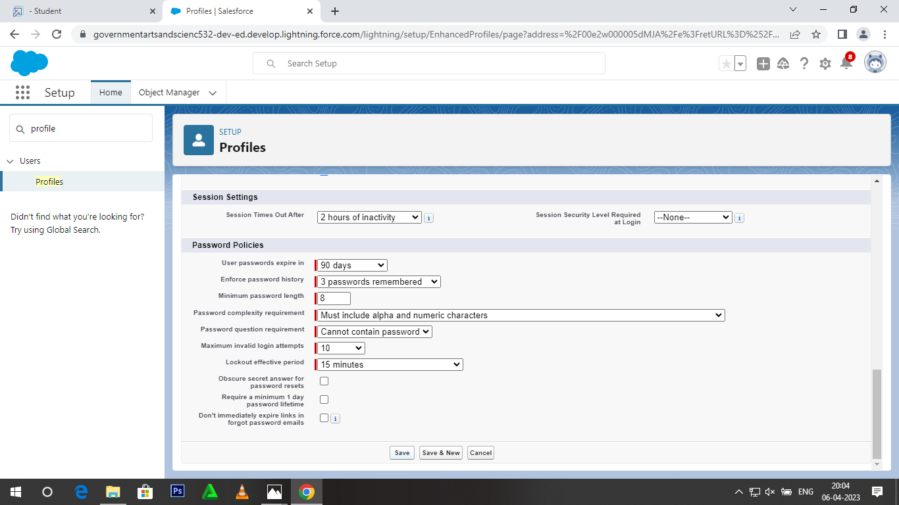

Activity-2

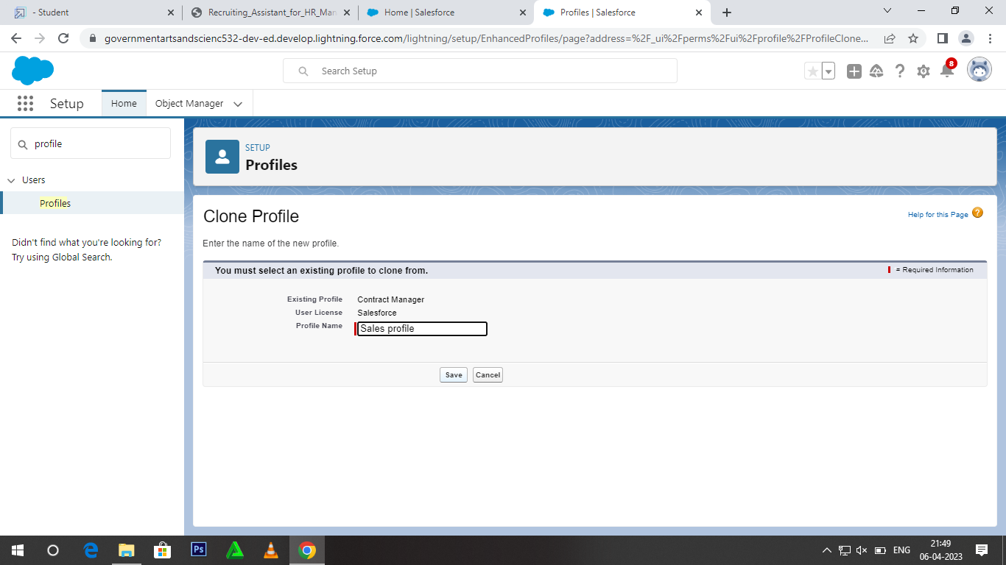

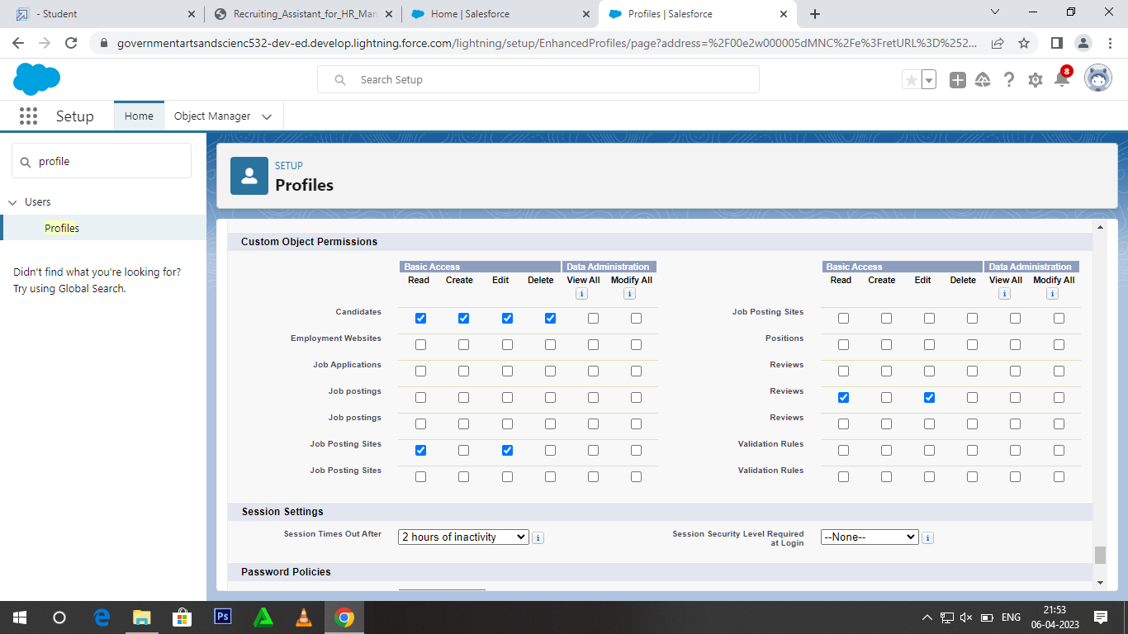

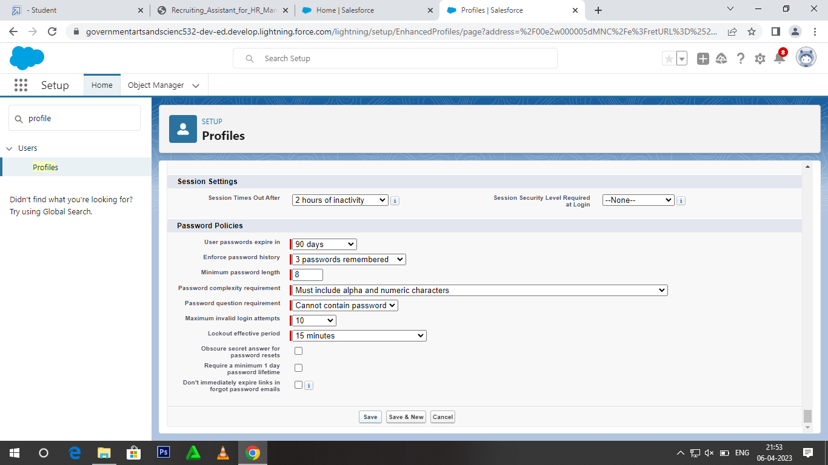

Milestone-10: Users

Activity-1

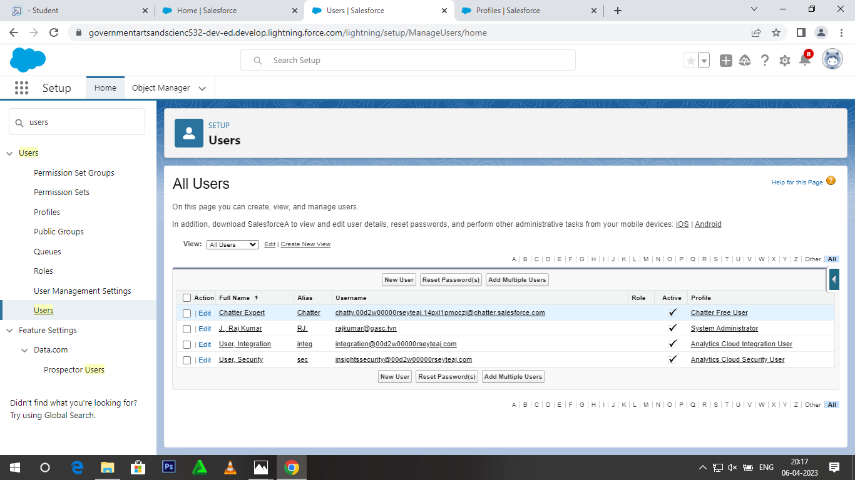

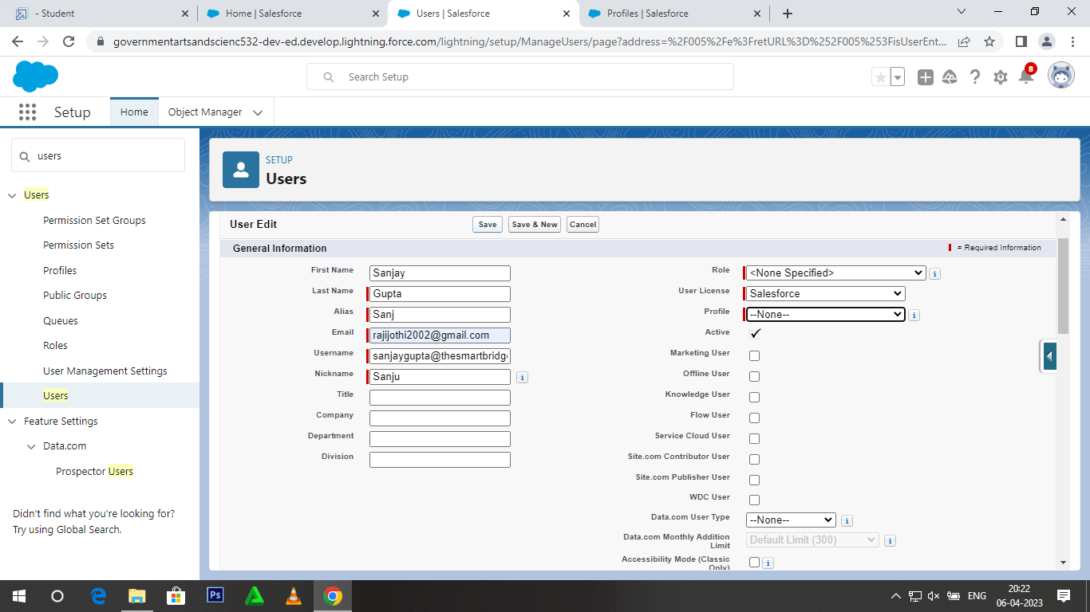

Activity-2

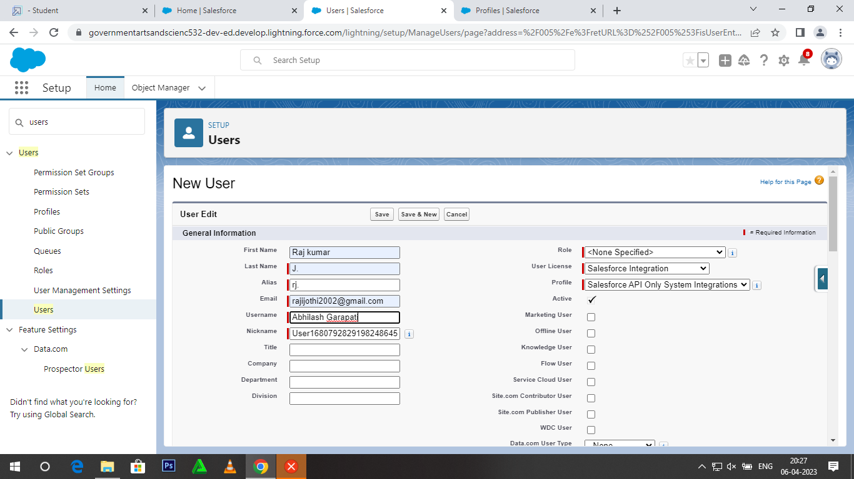

Milestone-11: Permission set

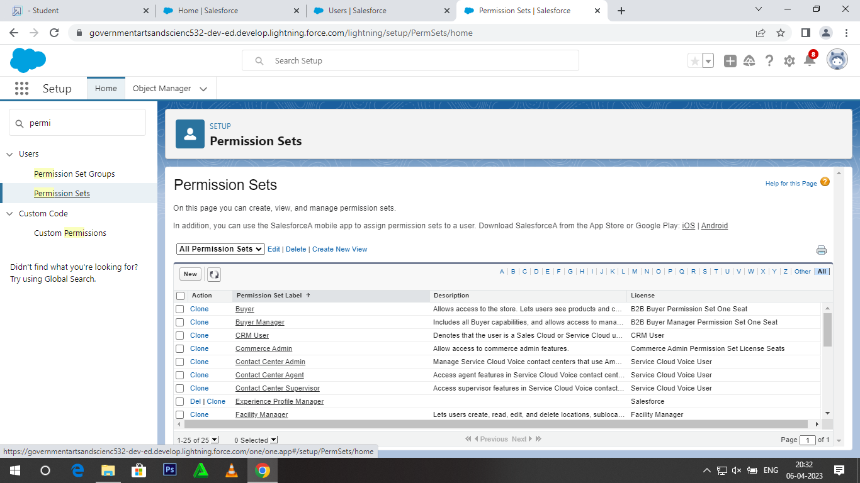

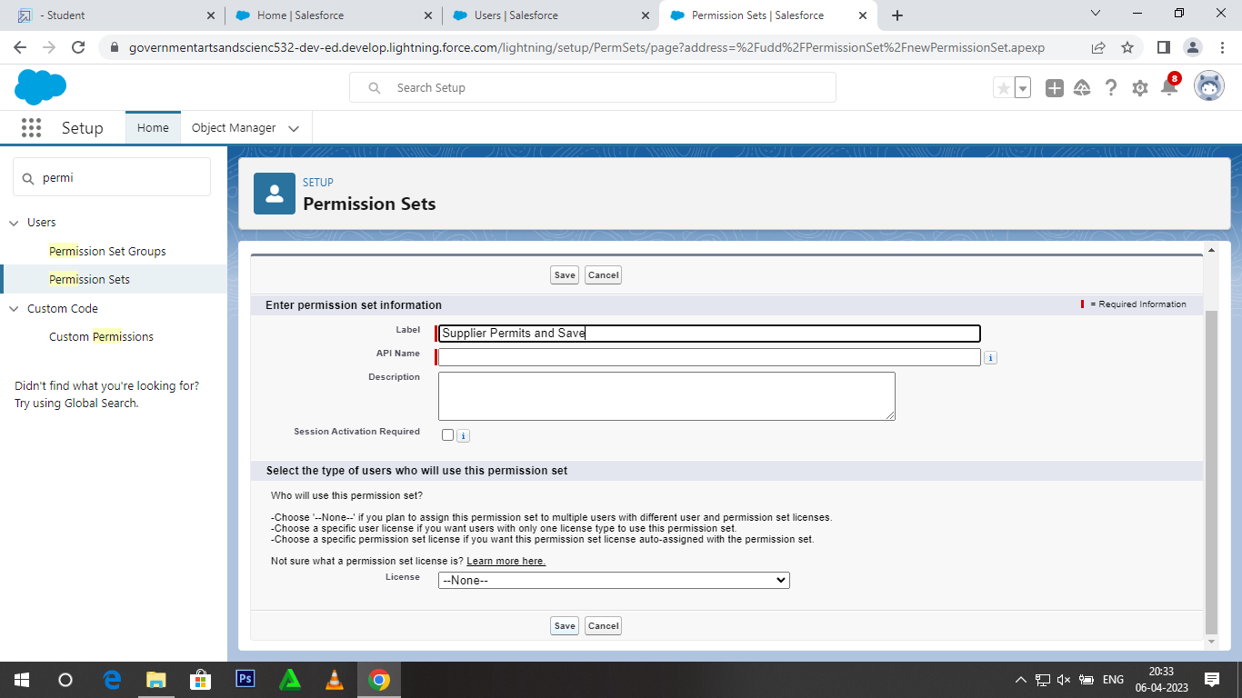

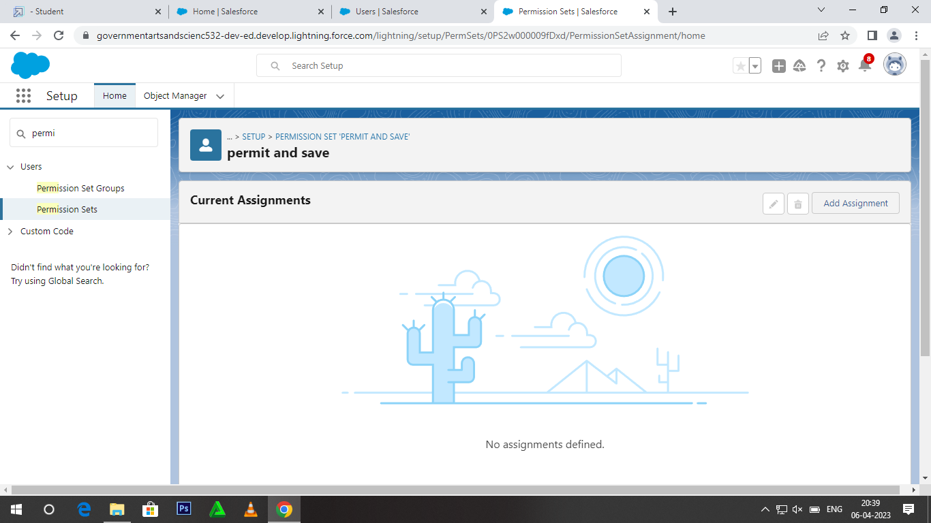

Milestone-12: Reports

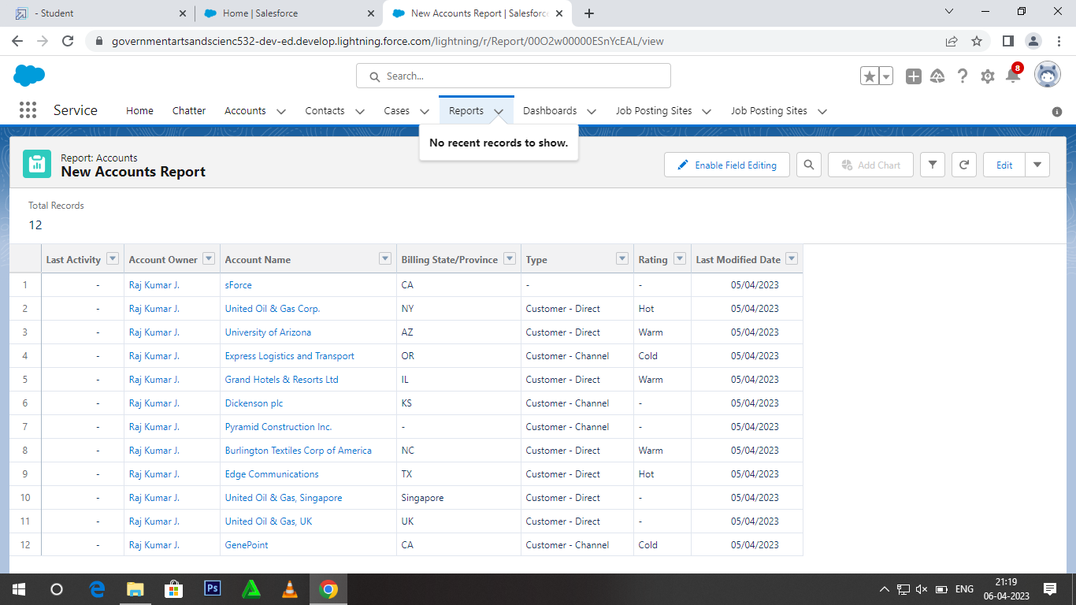

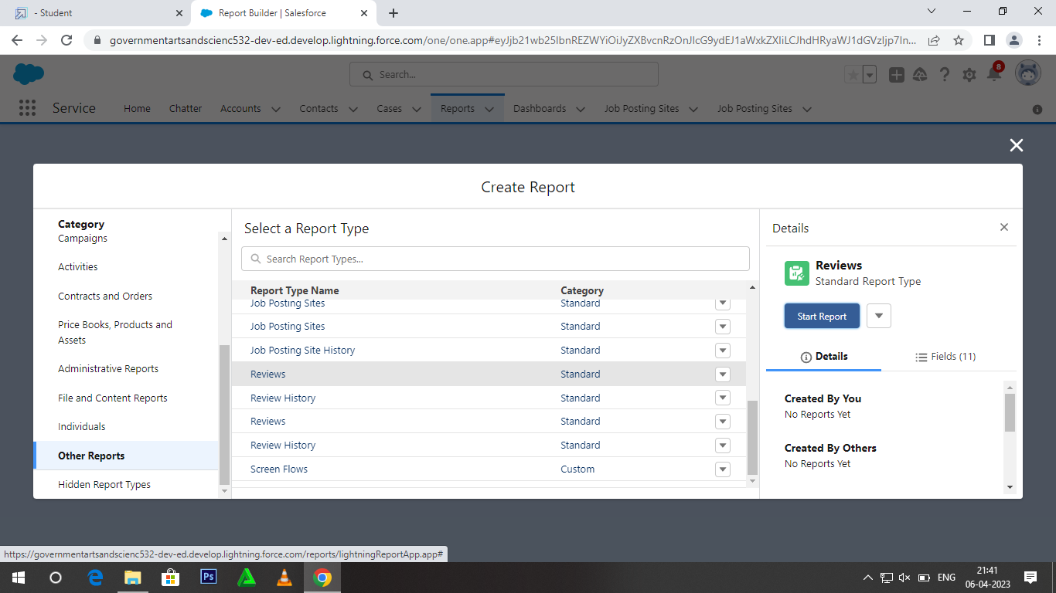

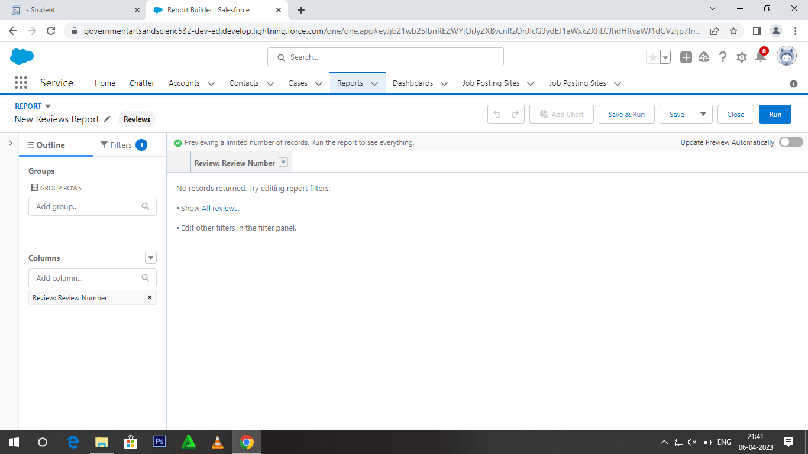

Activity-2

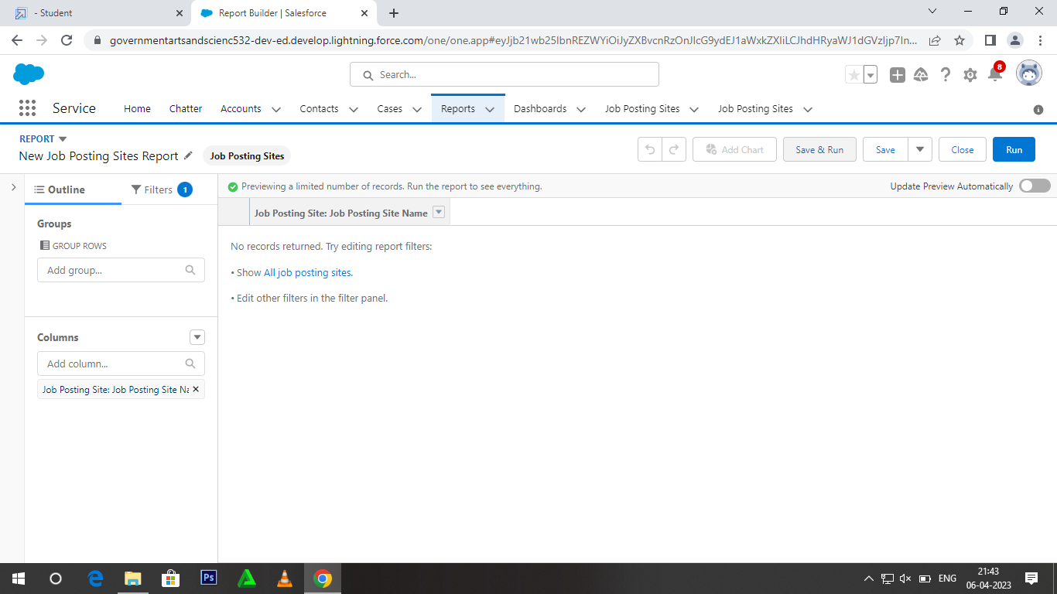

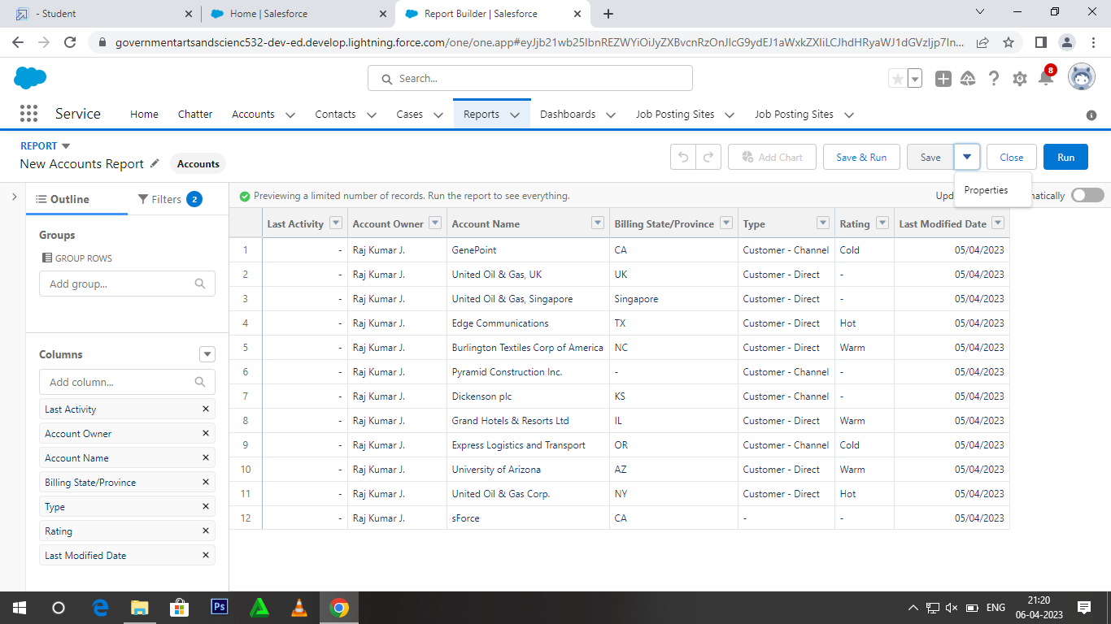

# 4. TRAILHEAD PROFILE PUBLIC URL

**Team Lead –** [trailblazer.me/id/rajkj1](https://trailblazer.me/id/rajkj1)

**Team Member 1 -**<http://trailblazer.me/id/rajvuesolutions>

**Team Member 2 –** <https://trailblazer.me/id/sanjm34>

**Team Member 3 -**<http://trailblazer.me/id/sarap89>

1. **ADVANTAGES & DISADVANTAGE**

# ADVANTAGES

It is the biggest and the best job for a person who likes to work and deal with people. In human resources, you get an opportunity to manage people working in the organization. This work can either be in terms of social work or it can be more clinical in nature.

Depending upon your degree and experience you may get to work in social welfare or maybe in tackling psychological problems.

**DISVANTAGES**

The working demand of the job is huge. Working with equipment or machine is completely different from working with people. There is no simple set of equations or list of instruction that can help you in dealing with problems related to humans.

So human resource managers and workers have to learn in their own way to manage and adjust with the difficult situation of this career.

# APPLICATIONS

Job Description Human Resources Assistant, Human Resources (HR) Assistant is a professional who is responsible for the daily administrative and HR duties of an organization. They assist with recruitment and record maintenance for payroll processing as well as provide clerical support to all employees.

# CONCLUSION

Study began with a basic curiosity of researcher based on academic exposure in HR and some questions raised in the mind after getting work exposure in development sector. Field of Human Resource Management has gone through an evolution process and has started playing a strategic role in industries. Generation of knowledge in HR has happened mainly on the basis of requirements in industrial sector. Development Sector Organizations that are Non-profit in nature and also comparatively smaller in employee strength have not been much in to consideration while generating this knowledge. Thus concepts and principles of HR based on this knowledge may have relevance in this sector but while implementing them, contextual understanding is required.

# FUTURE SCOPE

The scope is always high, request you to learn more and more about the techniques of recruitment this will help you in industry. Scope for HR is promising, there are many specialities in HR you can choose to master your career in. Recruitment is one of the speciality most sought after by consultancies and corporate.